
COMMUNITY DEVELOPMENT DEPARTMENT
Quincy Yaley, AICP
Director

48 Yaney Avenue, Sonora
Mailing: 2 S. Green Street
Sonora, CA 95370
(209) 533-5633
(209) 533-5616 (Fax)
(209) 533-5909 (Fax – EHD)
www.tuolumnecounty.ca.gov
Land Use and Natural Resources – Housing and Community Programs – Environmental Health – Building and Safety – Code Compliance

Supervisor District #: Kirk

Date: August 18, 2025

To: Interested Stakeholder

From: Tuolumne County Community Development Department

RE: LUNR-25-15

Assessor’s Parcel Numbers: 062-550-007

The Community Development Department appreciates your participation in the land development process in Tuolumne County. Your early input aids in identifying and addressing potential issues and supports an informed project review.

Applicant/Owner: James Wilkinson

Project: Zone Change LUNR-25-15 to rezone an approximately 0.58± acre portion of a 5.9± acre parcel from RE-2 (Residential Estate, Two Acre Minimum) to RE-5 (Residential Estate, Five Acre Minimum) under Title 17 of the Tuolumne County Ordinance Code.

Location: The project site is located along Mira Monte Road in Tuolumne, approximately half a mile from the intersection of Mira Monte Road and Buchanan Road. Assessor’s Parcel Number 062-550-006.
Additional Information:
- The Zone Change is required to allow for a Lot Line Adjustment to adjust the 0.58-acre portion from APN 062-550-007 to APN 062-550-006.
Zoning: RE-2
Proposed Zoning: RE-5
General Plan: ER
Access: Mira Monte Road

Sewage Disposal Method: Private Septic

Water Source: Public

Fire Hazard Rating: Very High

Please return your comments to the CDD by September 1, 2025.

Staff Contact: Natalie Rizzi

Phone: (209) 533-5936

Email: nrizzi@co.tuolumne.ca.us

S:\Planning\PROJECTS\LUNR Projects\2025\LUNR-25-15 Wilkinson (RZ)\Application Review\Stakeholder Notification Template.docx

Attachment 1: Vicinity Map
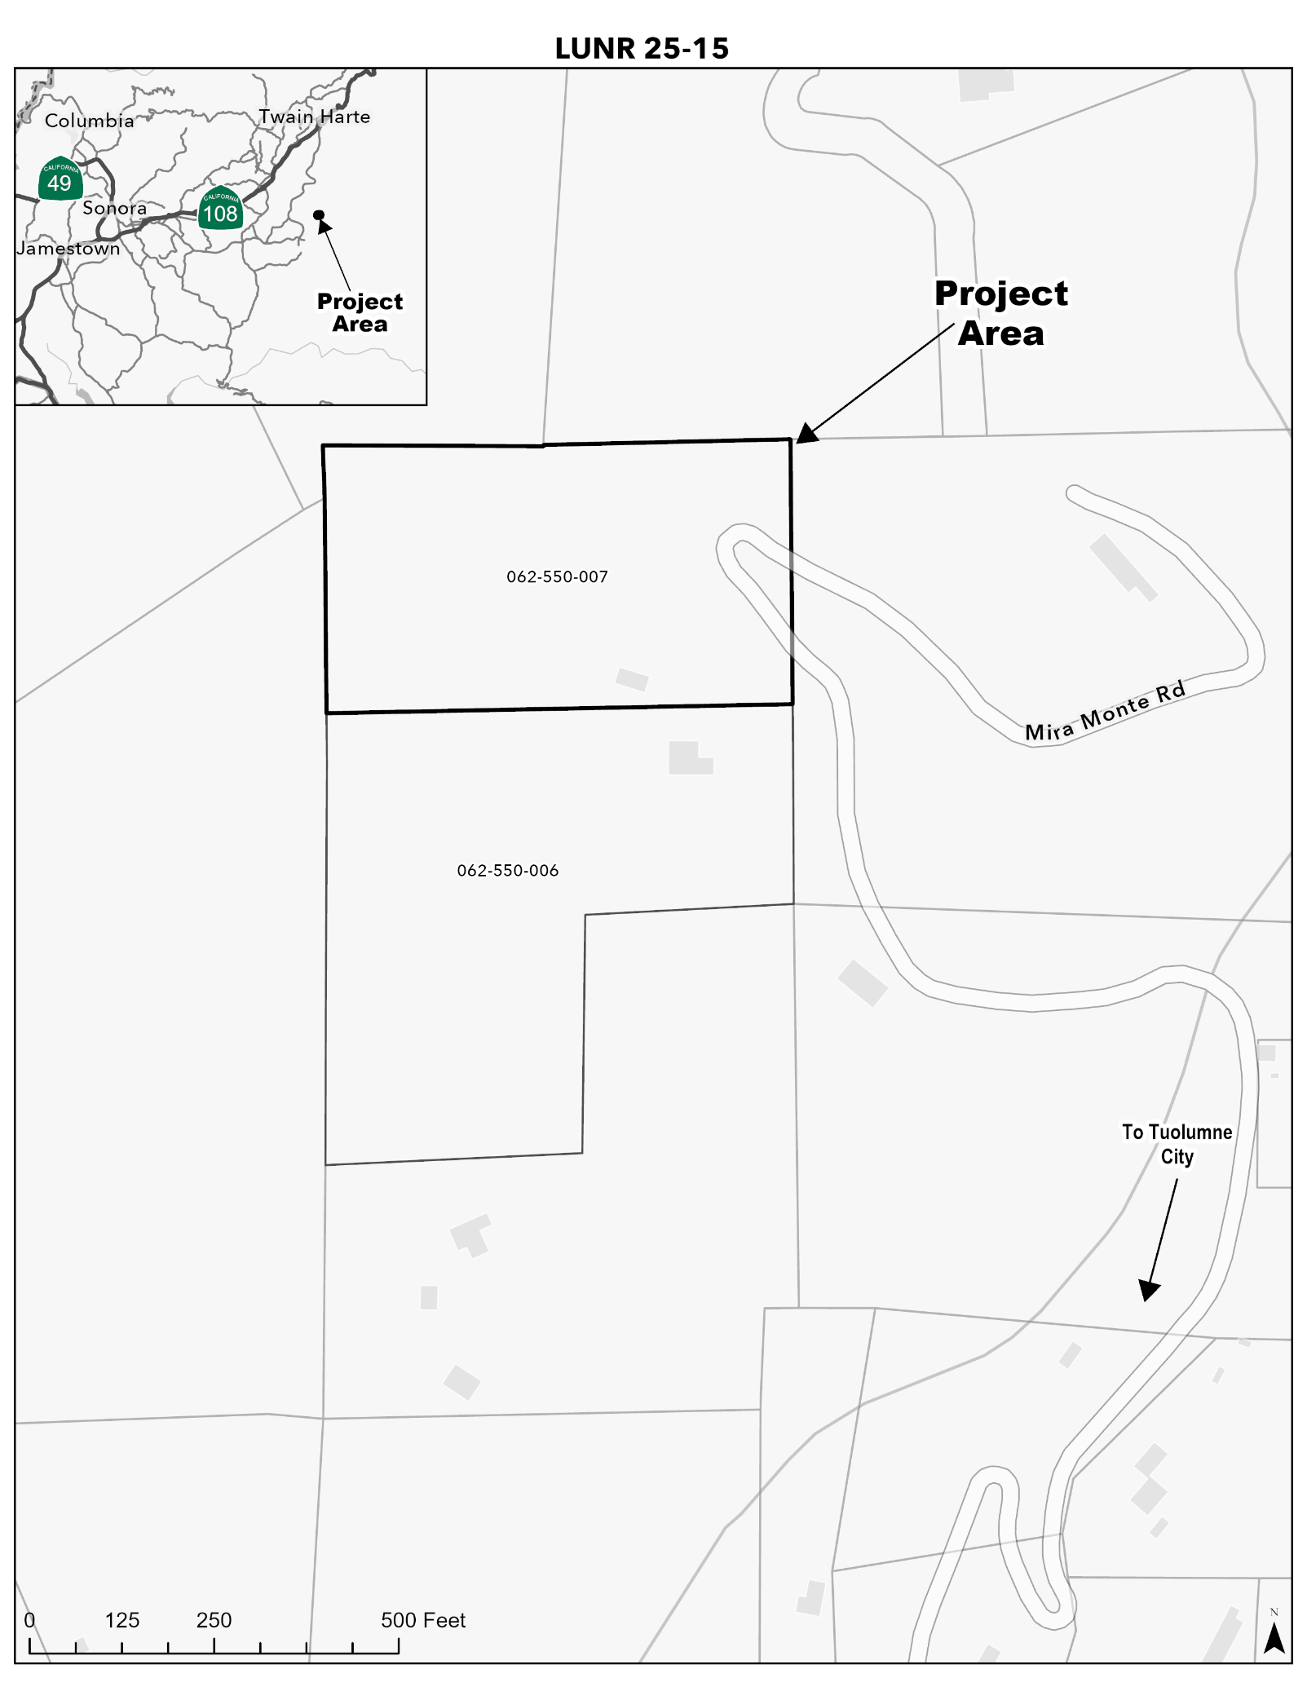
Attachment 2: Exhibit Map

